Kosrae: Celebration of Fafa Pounding
Essay and photos by Joyminda George, Canita Rilometo Nakamura, & Mayble Sigrah
November 2018

In August 2018, GEM ISLET members in Kosrae helped to coordinate a fafa pounding event with youth. Both young men and women took the lead on preparing the pounded taro and pounded taro and banana delicacies, with guidance from elders.

1. Young fafa pounder prepares soft taro fafa with only taro and a small amount of water to keep his hands, board, and stone clean.

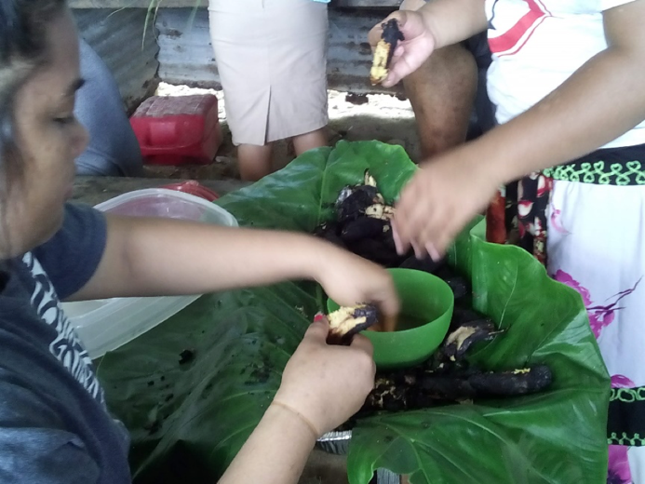
2. Adult and young women prepare grilled ripe bananas for the fafa pounding.

3. Women weave fafa baskets while fafa is being pounded.
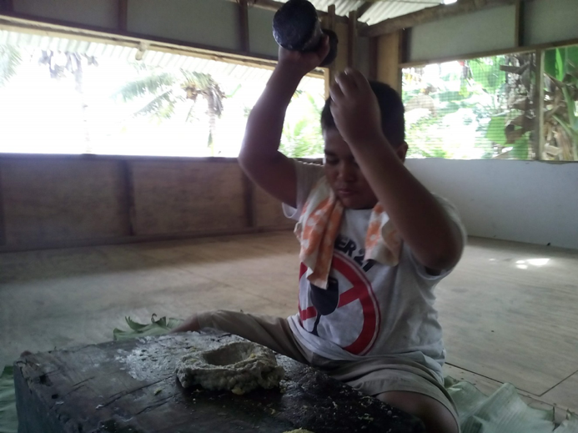
4. Another fafa pounder prepares fafa with soft taro and grilled ripe bananas.
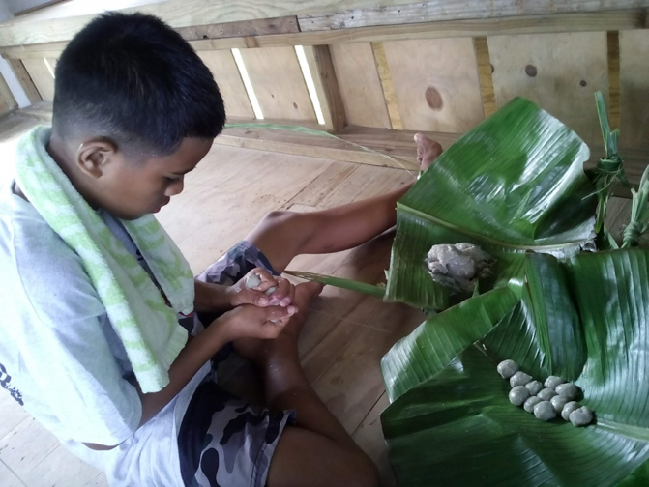
5. Soft taro fafa shaped into small balls before adding topping.
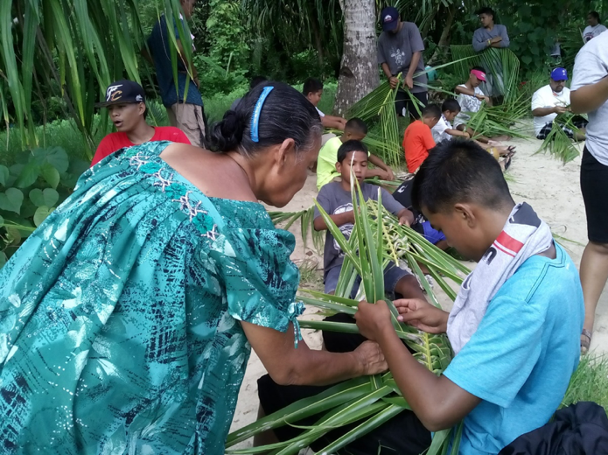
6. Lelu youth weave baskets with the help of their elders.
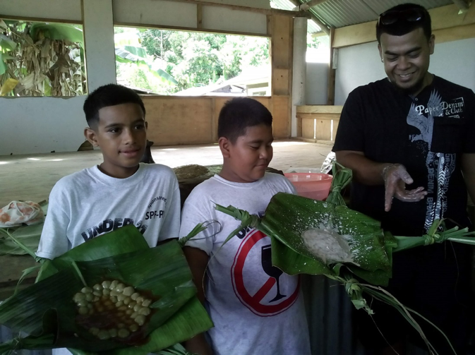
7. Young fafa pounders show off their finished products: fafa made with soft taro and topped with sweetened coconut cream caramel (left) and fafa made with grilled ripe bananas and topped with freshly squeezed coconut cream (right).
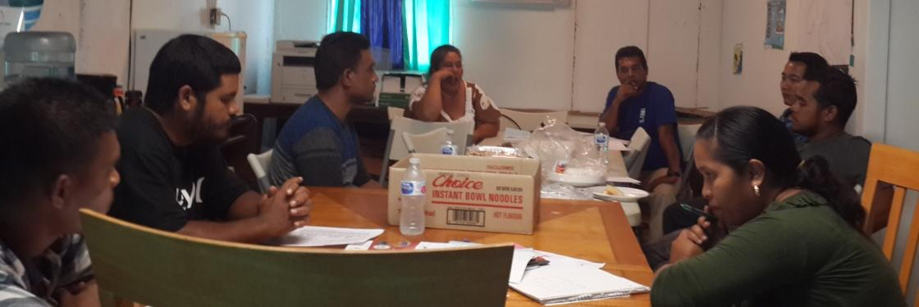
8. Geoscience in Education ISLET members meet to plan and discuss about fafa pounding project.

